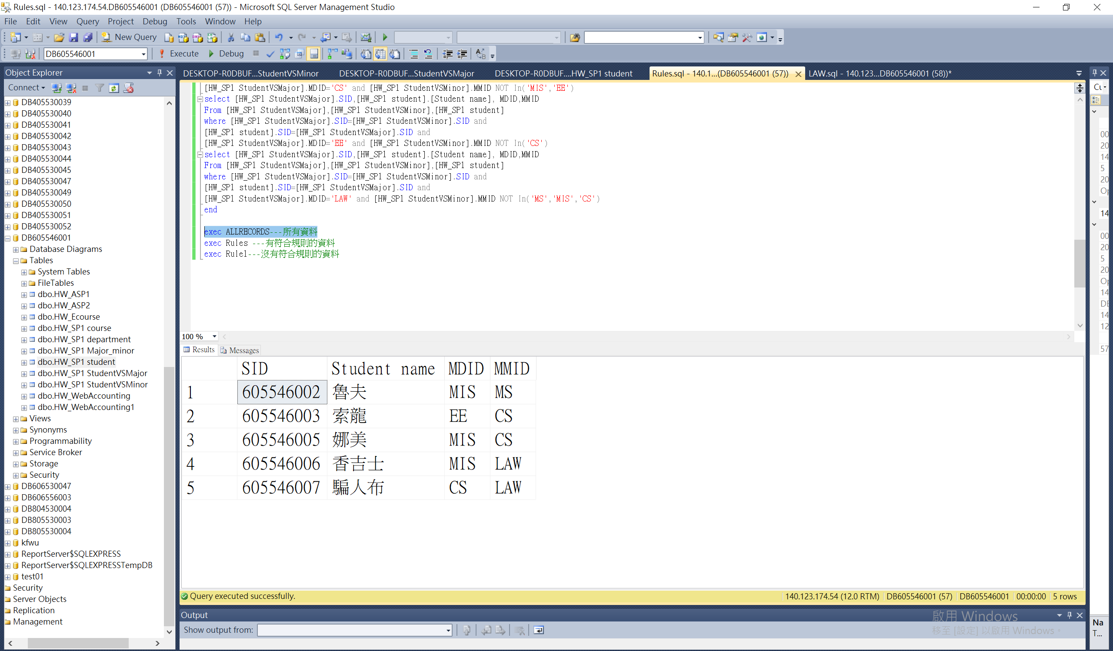

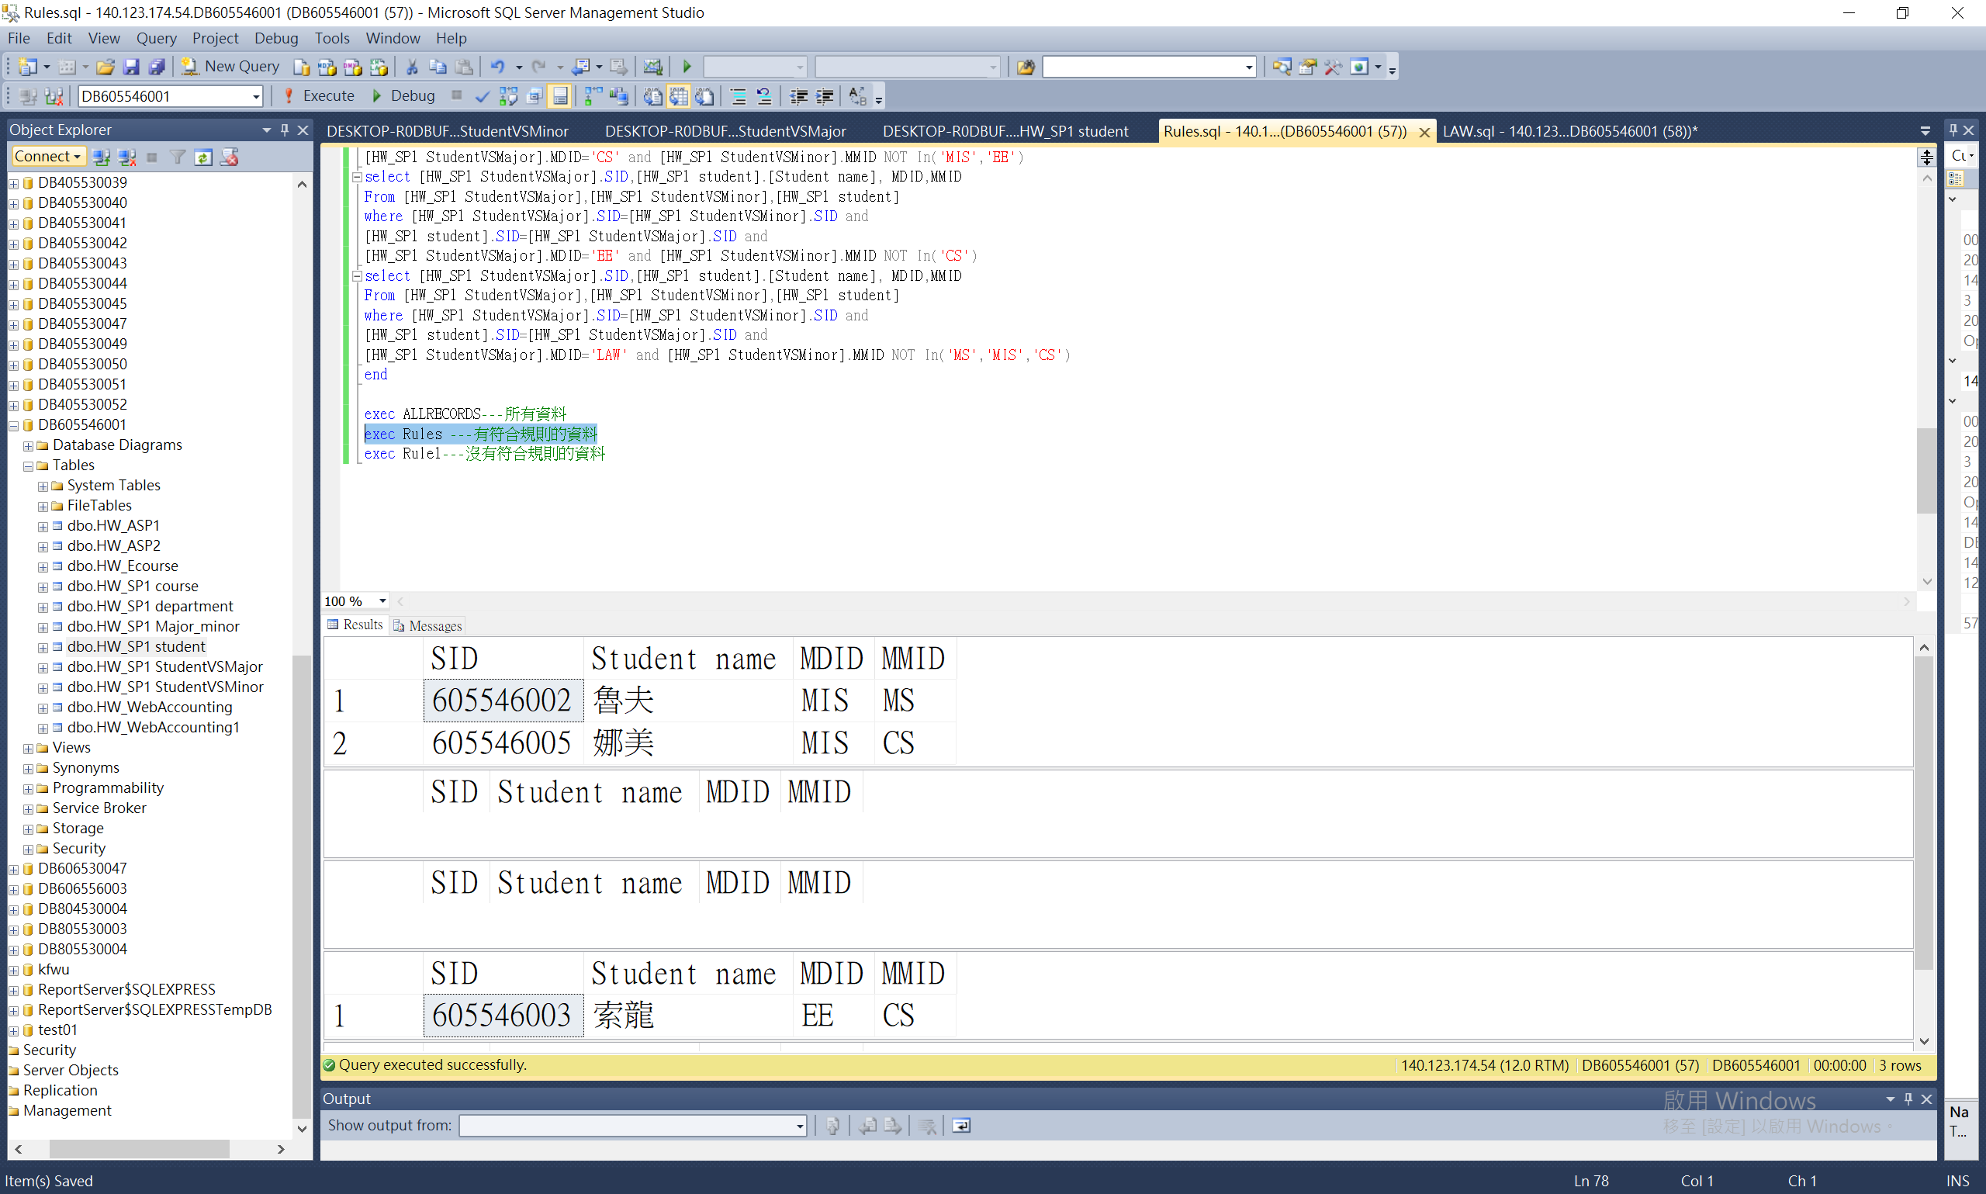

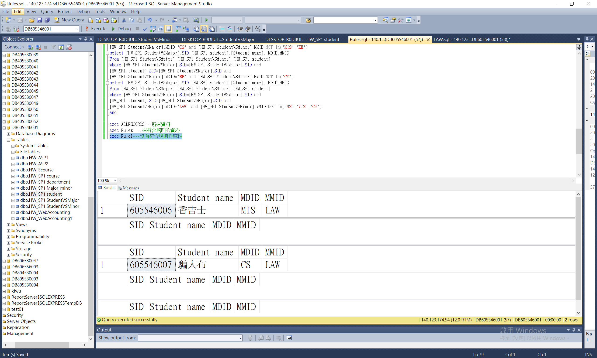alter procedure ALLRECORDS

as

begin

select [HW_SP1 StudentVSMajor].SID,[HW_SP1 student].[Student name], MDID,MMID

From [HW_SP1 StudentVSMajor],[HW_SP1 StudentVSMinor],[HW_SP1 student]

where [HW_SP1 StudentVSMajor].SID=[HW_SP1 StudentVSMinor].SID and

[HW_SP1 student].SID=[HW_SP1 StudentVSMajor].SID

end

go

alter procedure Rules

as

begin

select [HW_SP1 StudentVSMajor].SID,[HW_SP1 student].[Student name], MDID,MMID

From [HW_SP1 StudentVSMajor],[HW_SP1 StudentVSMinor],[HW_SP1 student]

where [HW_SP1 StudentVSMajor].SID=[HW_SP1 StudentVSMinor].SID and

[HW_SP1 student].SID=[HW_SP1 StudentVSMajor].SID and

[HW_SP1 StudentVSMajor].MDID='MIS' and [HW_SP1 StudentVSMinor].MMID in('MS','CS')

select [HW_SP1 StudentVSMajor].SID,[HW_SP1 student].[Student name], MDID,MMID

From [HW_SP1 StudentVSMajor],[HW_SP1 StudentVSMinor],[HW_SP1 student]

where [HW_SP1 StudentVSMajor].SID=[HW_SP1 StudentVSMinor].SID and

[HW_SP1 student].SID=[HW_SP1 StudentVSMajor].SID and

[HW_SP1 StudentVSMajor].MDID='MS' and [HW_SP1 StudentVSMinor].MMID In('MIS','LAW')

select [HW_SP1 StudentVSMajor].SID,[HW_SP1 student].[Student name], MDID,MMID

From [HW_SP1 StudentVSMajor],[HW_SP1 StudentVSMinor],[HW_SP1 student]

where [HW_SP1 StudentVSMajor].SID=[HW_SP1 StudentVSMinor].SID and

[HW_SP1 student].SID=[HW_SP1 StudentVSMajor].SID and

[HW_SP1 StudentVSMajor].MDID='CS' and [HW_SP1 StudentVSMinor].MMID In('MIS','EE')

select [HW_SP1 StudentVSMajor].SID,[HW_SP1 student].[Student name], MDID,MMID

From [HW_SP1 StudentVSMajor],[HW_SP1 StudentVSMinor],[HW_SP1 student]

where [HW_SP1 StudentVSMajor].SID=[HW_SP1 StudentVSMinor].SID and

[HW_SP1 student].SID=[HW_SP1 StudentVSMajor].SID and

[HW_SP1 StudentVSMajor].MDID='EE' and [HW_SP1 StudentVSMinor].MMID In('CS')

select [HW_SP1 StudentVSMajor].SID,[HW_SP1 student].[Student name], MDID,MMID

From [HW_SP1 StudentVSMajor],[HW_SP1 StudentVSMinor],[HW_SP1 student]

where [HW_SP1 StudentVSMajor].SID=[HW_SP1 StudentVSMinor].SID and

[HW_SP1 student].SID=[HW_SP1 StudentVSMajor].SID and

[HW_SP1 StudentVSMajor].MDID='LAW' and [HW_SP1 StudentVSMinor].MMID In('MS','MIS','CS')

end

go

alter procedure Rule1

as

begin

select [HW_SP1 StudentVSMajor].SID,[HW_SP1 student].[Student name], MDID,MMID

From [HW_SP1 StudentVSMajor],[HW_SP1 StudentVSMinor],[HW_SP1 student]

where [HW_SP1 StudentVSMajor].SID=[HW_SP1 StudentVSMinor].SID and

[HW_SP1 student].SID=[HW_SP1 StudentVSMajor].SID and

[HW_SP1 StudentVSMajor].MDID='MIS' and [HW_SP1 StudentVSMinor].MMID not in('MS','CS')

select [HW_SP1 StudentVSMajor].SID,[HW_SP1 student].[Student name], MDID,MMID

From [HW_SP1 StudentVSMajor],[HW_SP1 StudentVSMinor],[HW_SP1 student]

where [HW_SP1 StudentVSMajor].SID=[HW_SP1 StudentVSMinor].SID and

[HW_SP1 student].SID=[HW_SP1 StudentVSMajor].SID and

[HW_SP1 StudentVSMajor].MDID='MS' and [HW_SP1 StudentVSMinor].MMID NOT In('MIS','LAW')

select [HW_SP1 StudentVSMajor].SID,[HW_SP1 student].[Student name], MDID,MMID

From [HW_SP1 StudentVSMajor],[HW_SP1 StudentVSMinor],[HW_SP1 student]

where [HW_SP1 StudentVSMajor].SID=[HW_SP1 StudentVSMinor].SID and

[HW_SP1 student].SID=[HW_SP1 StudentVSMajor].SID and

[HW_SP1 StudentVSMajor].MDID='CS' and [HW_SP1 StudentVSMinor].MMID NOT In('MIS','EE')

select [HW_SP1 StudentVSMajor].SID,[HW_SP1 student].[Student name], MDID,MMID

From [HW_SP1 StudentVSMajor],[HW_SP1 StudentVSMinor],[HW_SP1 student]

where [HW_SP1 StudentVSMajor].SID=[HW_SP1 StudentVSMinor].SID and

[HW_SP1 student].SID=[HW_SP1 StudentVSMajor].SID and

[HW_SP1 StudentVSMajor].MDID='EE' and [HW_SP1 StudentVSMinor].MMID NOT In('CS')

select [HW_SP1 StudentVSMajor].SID,[HW_SP1 student].[Student name], MDID,MMID

From [HW_SP1 StudentVSMajor],[HW_SP1 StudentVSMinor],[HW_SP1 student]

where [HW_SP1 StudentVSMajor].SID=[HW_SP1 StudentVSMinor].SID and

[HW_SP1 student].SID=[HW_SP1 StudentVSMajor].SID and

[HW_SP1 StudentVSMajor].MDID='LAW' and [HW_SP1 StudentVSMinor].MMID NOT In('MS','MIS','CS')

end

exec ALLRECORDS---所有資料

exec Rules ---有符合規則的資料

exec Rule1---沒有符合規則的資料